Supplementary Plots: Missing data patterns:

The six graphs presented below show the amount and patterns of missing data within the sample of data used in the paper “Bayesian hierarchical multidimensional item-response modelling of small sample, sparse data for personalised developmental surveillance”. The data for each functional domain is displayed on a separate graph. Each row is a subject and each column is a milestone, resulting in a *N* x *p* matrix of observations. The milestones are ordered from the first milestone 1.1, to the last milestone 34.1. If the observation is blue, the child achieved the milestone. If the observation is red, the child did not achieve that milestone and if it is grey the observation is missing. There are many more missing observations for the later milestones than the earlier ones. This is because the children are all different ages and therefore the majority are not old enough to have completed the later milestones yet. There is also variability between children in the number of observations completed, which is due to the level of engagement with the program. In total there is approximately 42% missing observations.

Missing data binary plot auditory:

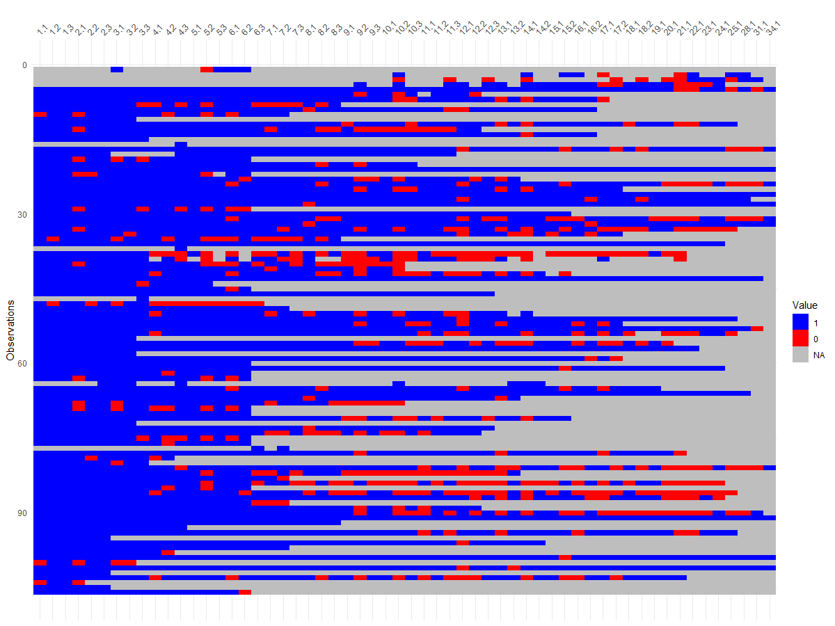

Missing data binary plot hands

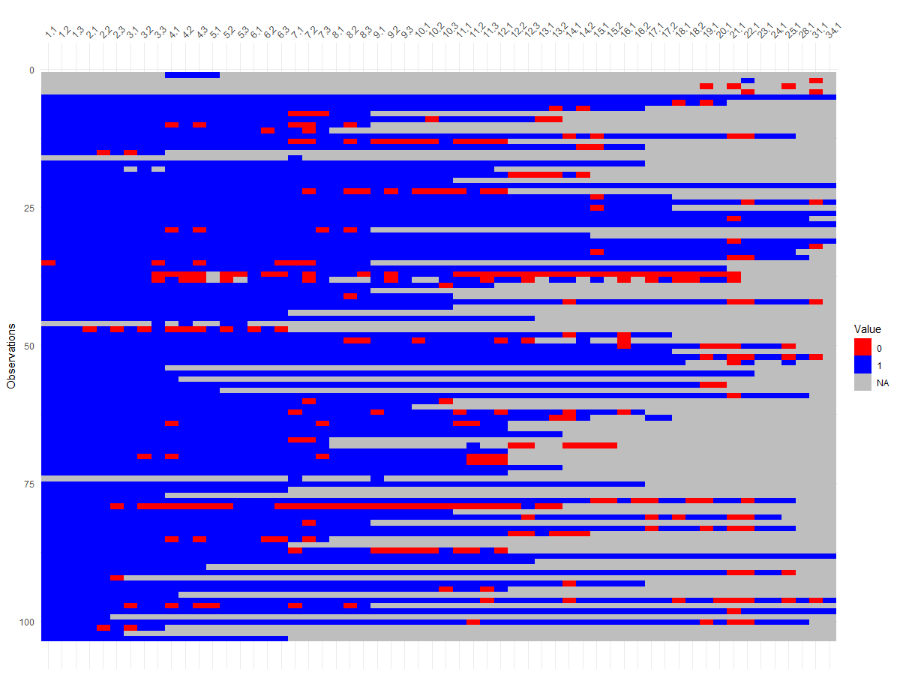

Missing data binary plot movement

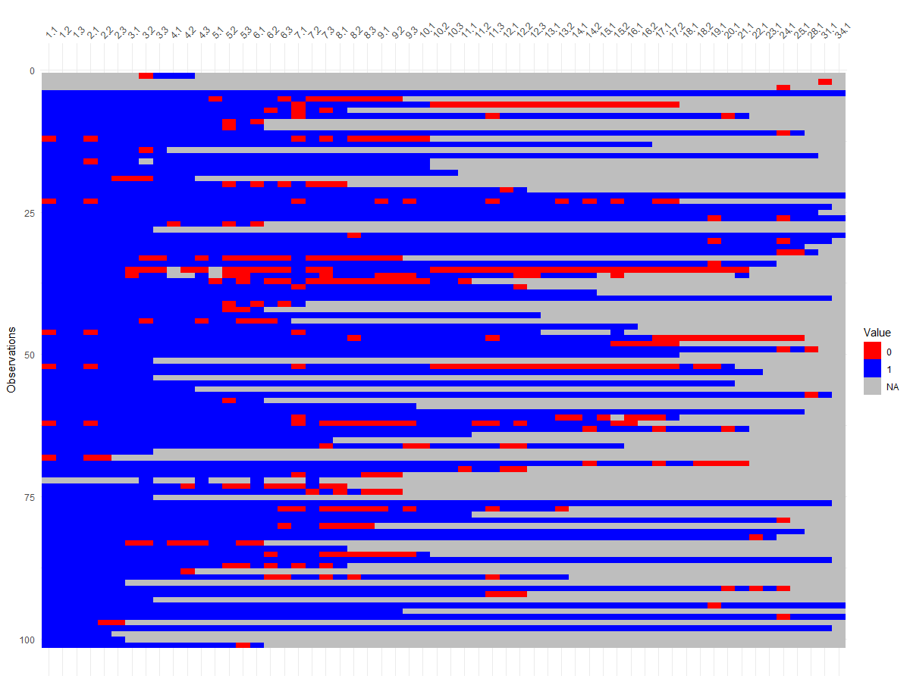

Missing data binary plot speech

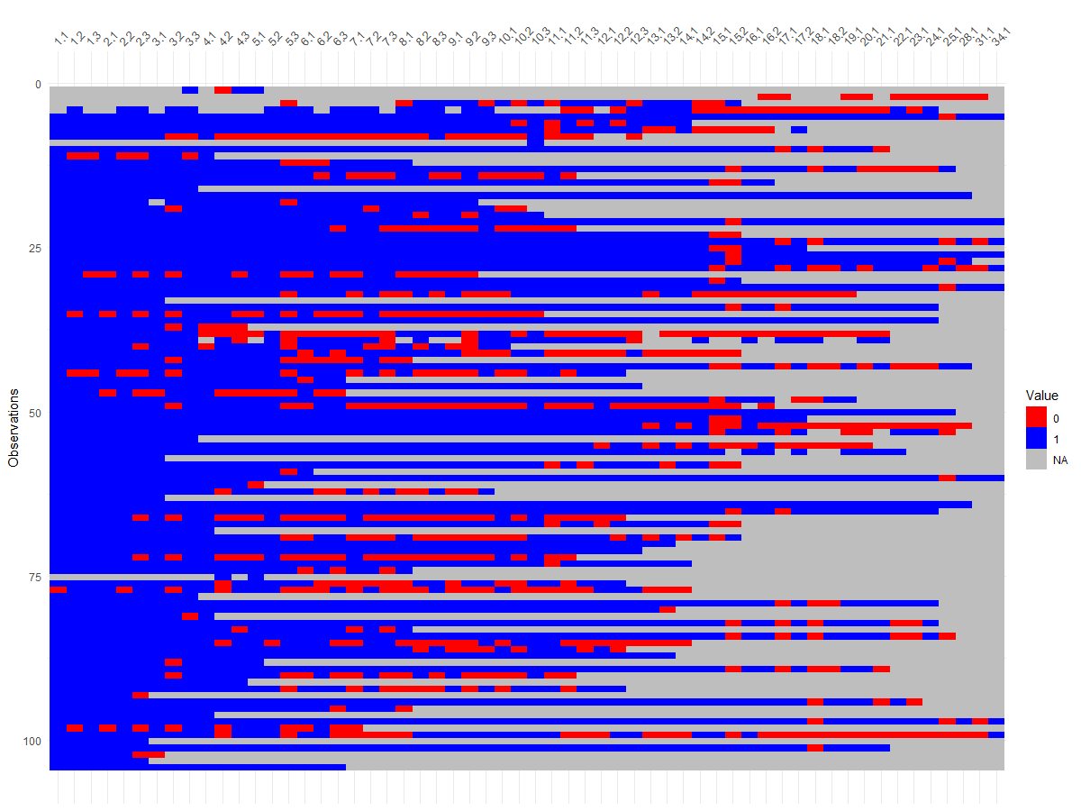

Missing data binary plot tactile

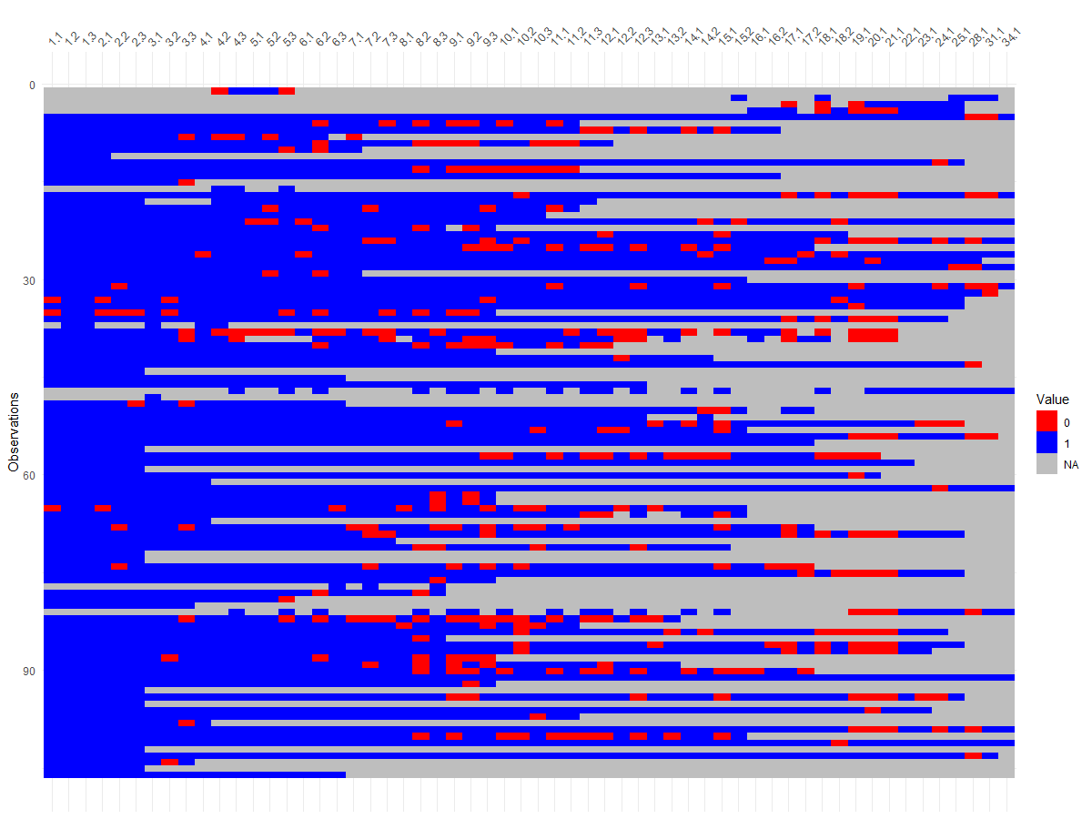

Missing data binary plot vision

